Screenshots
Keyword Research - Selected Keywords (Practo Hyderabad)

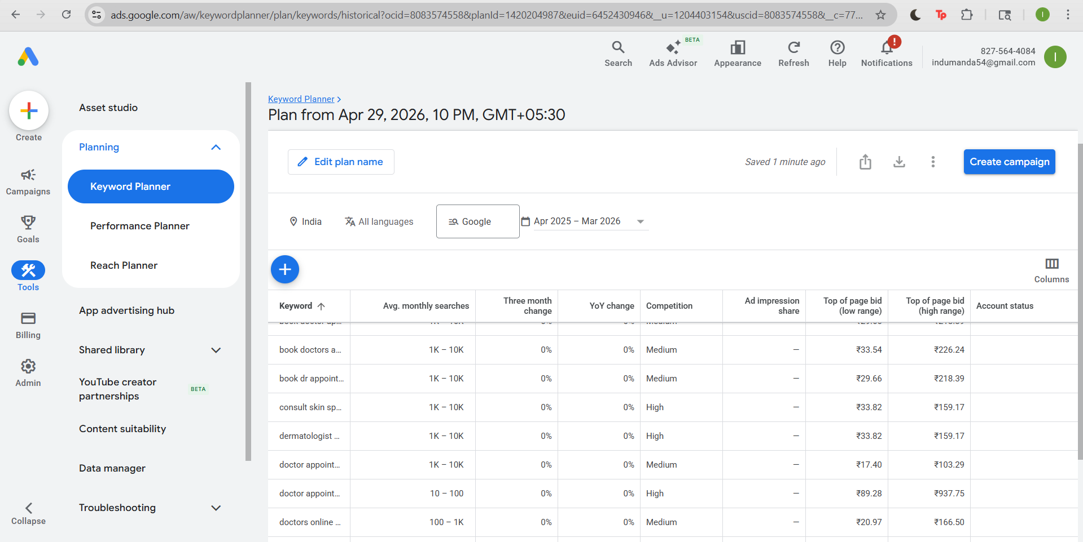

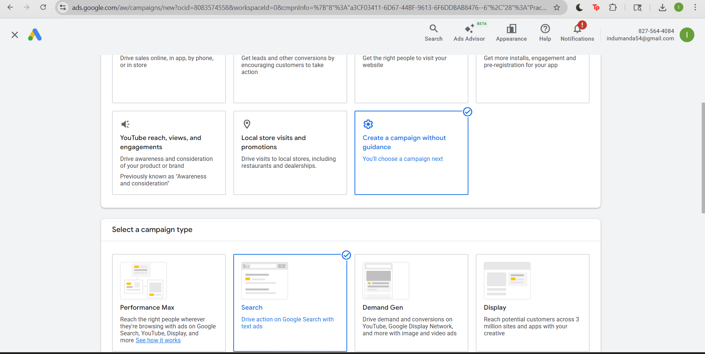

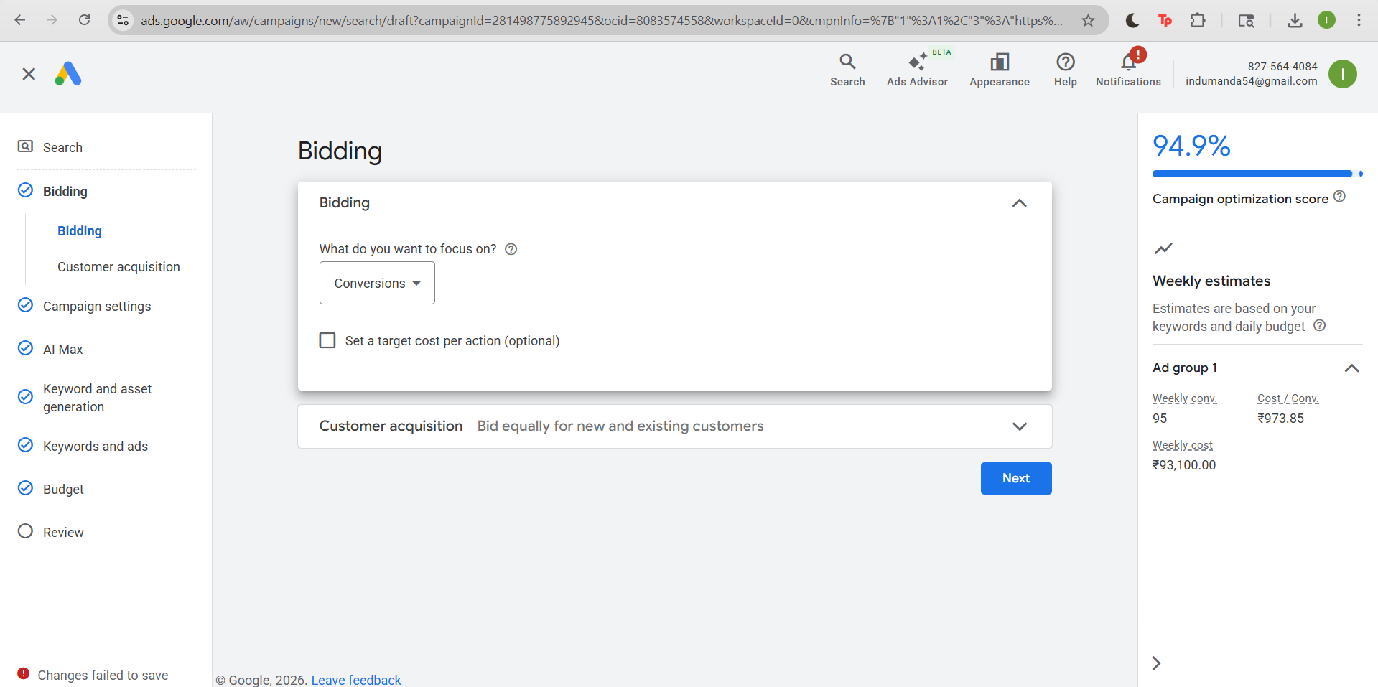

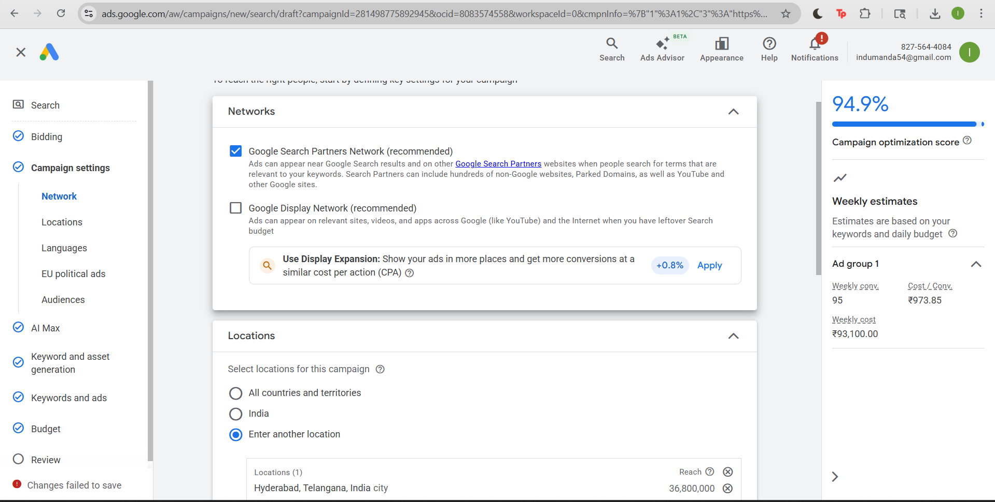

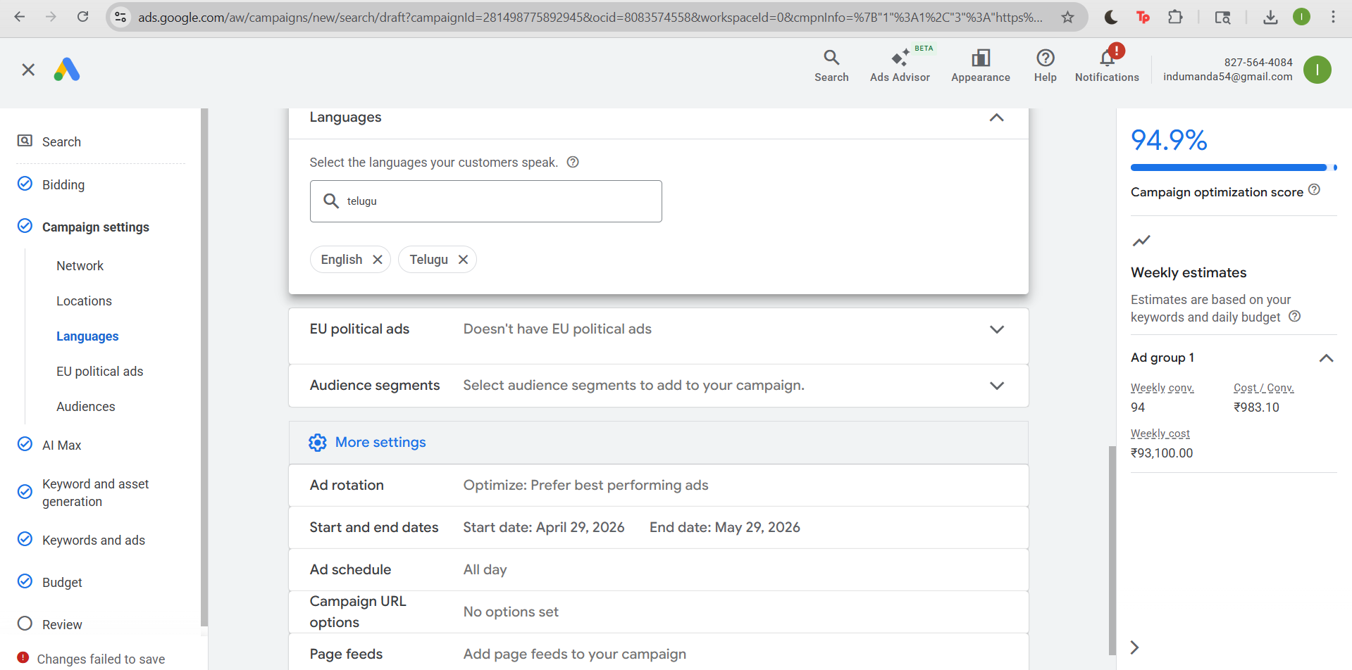

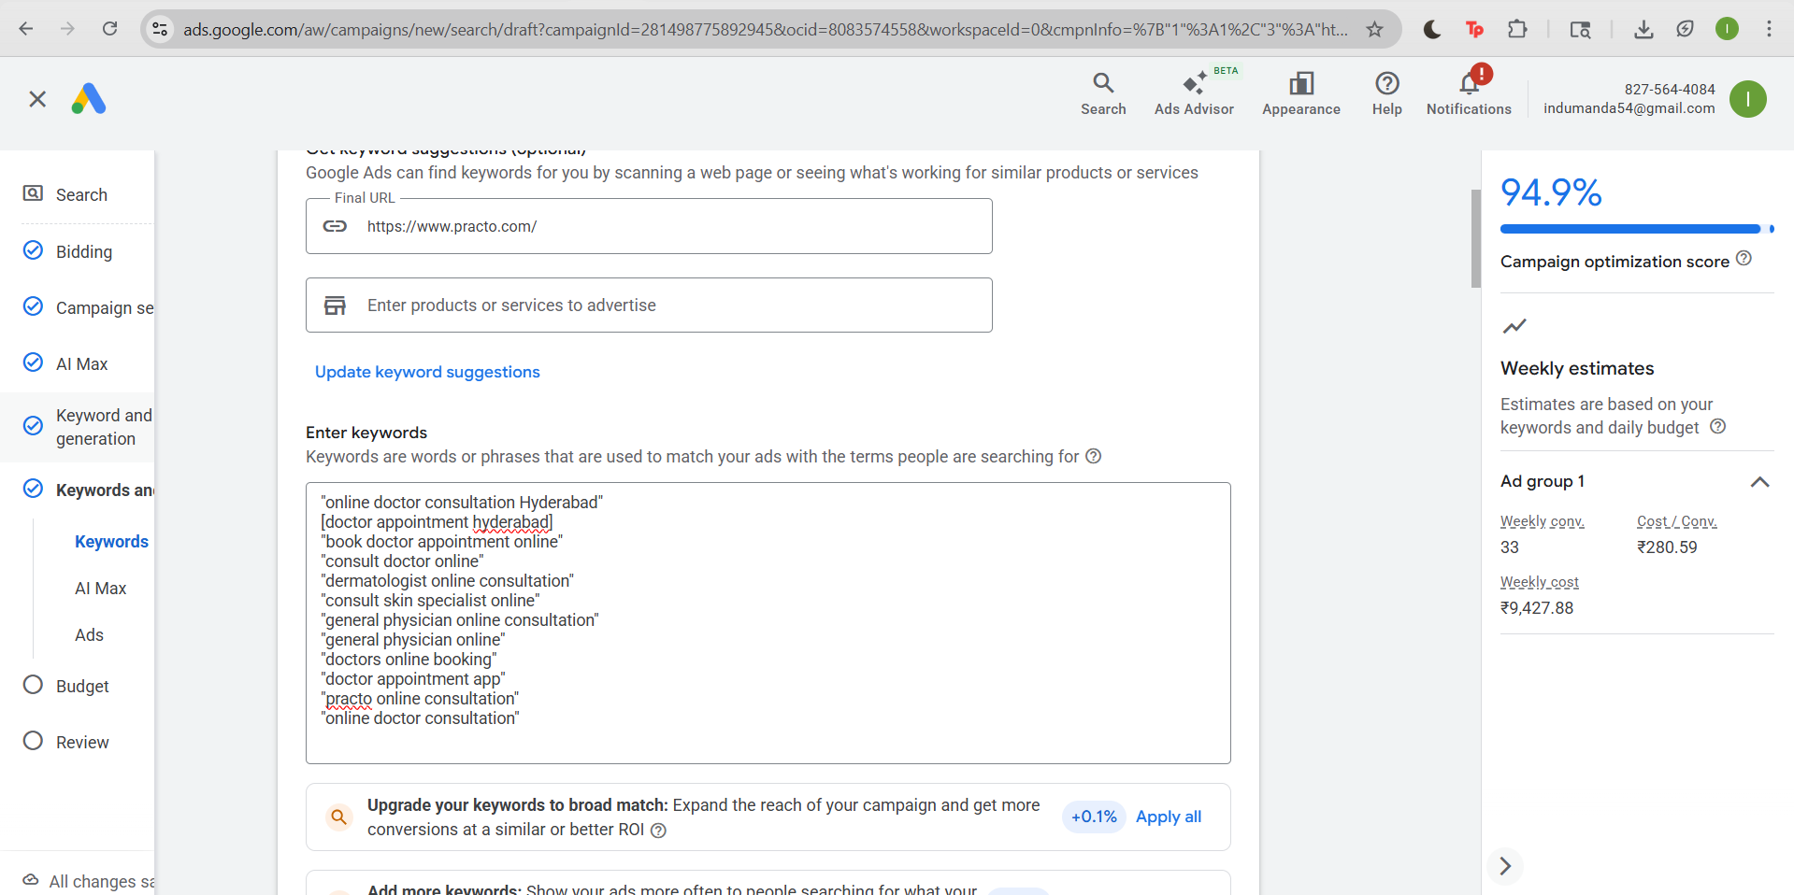

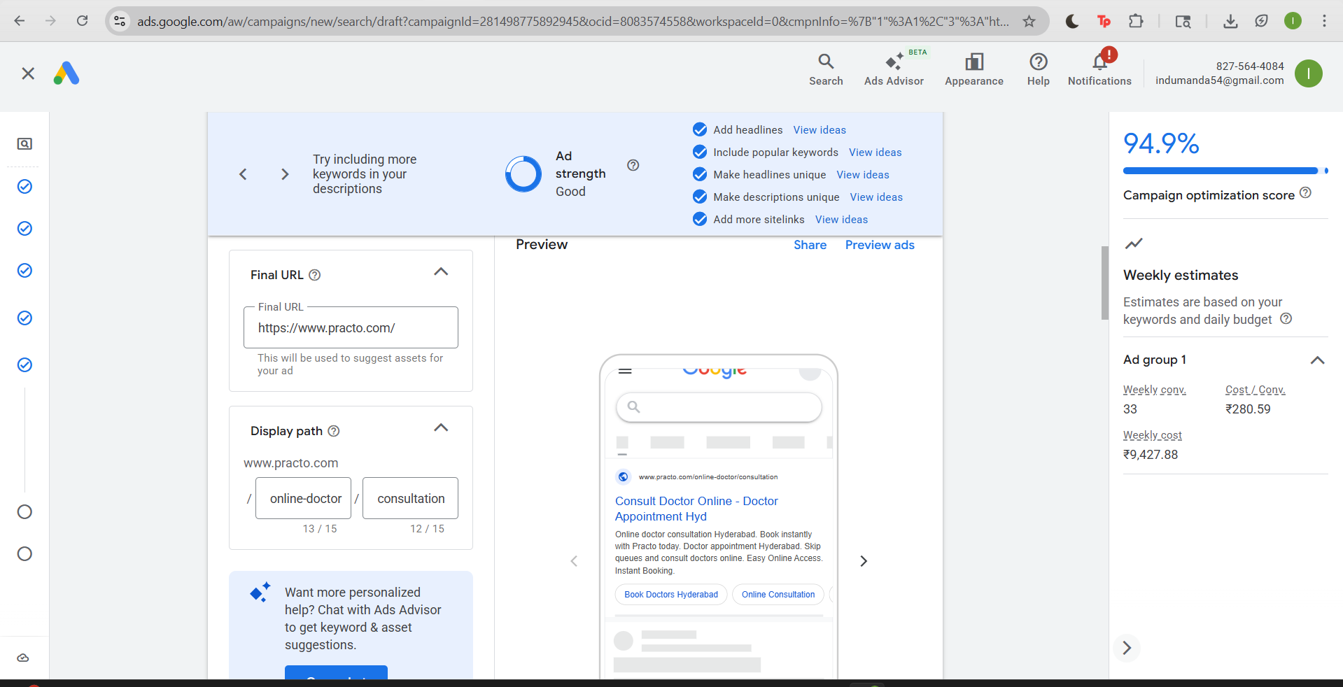

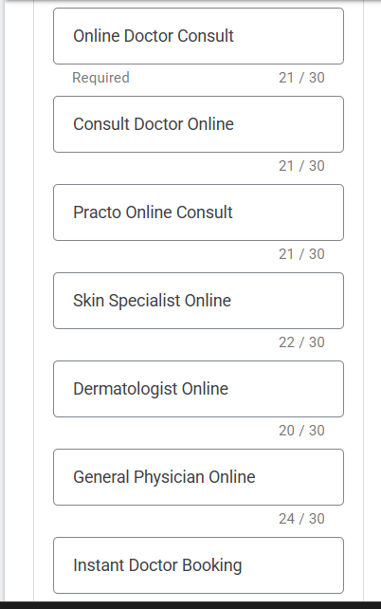

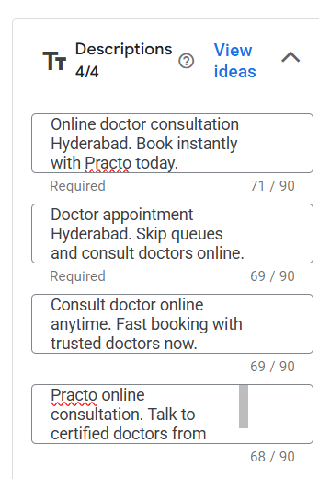

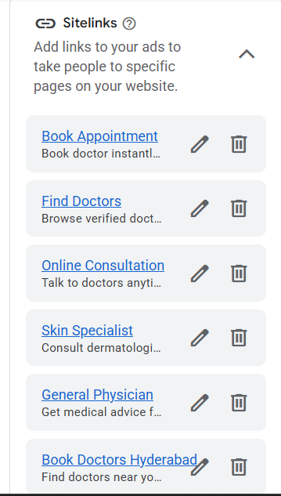

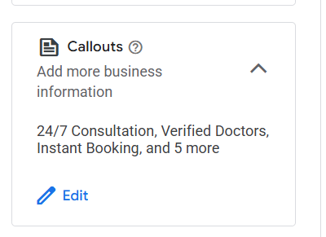

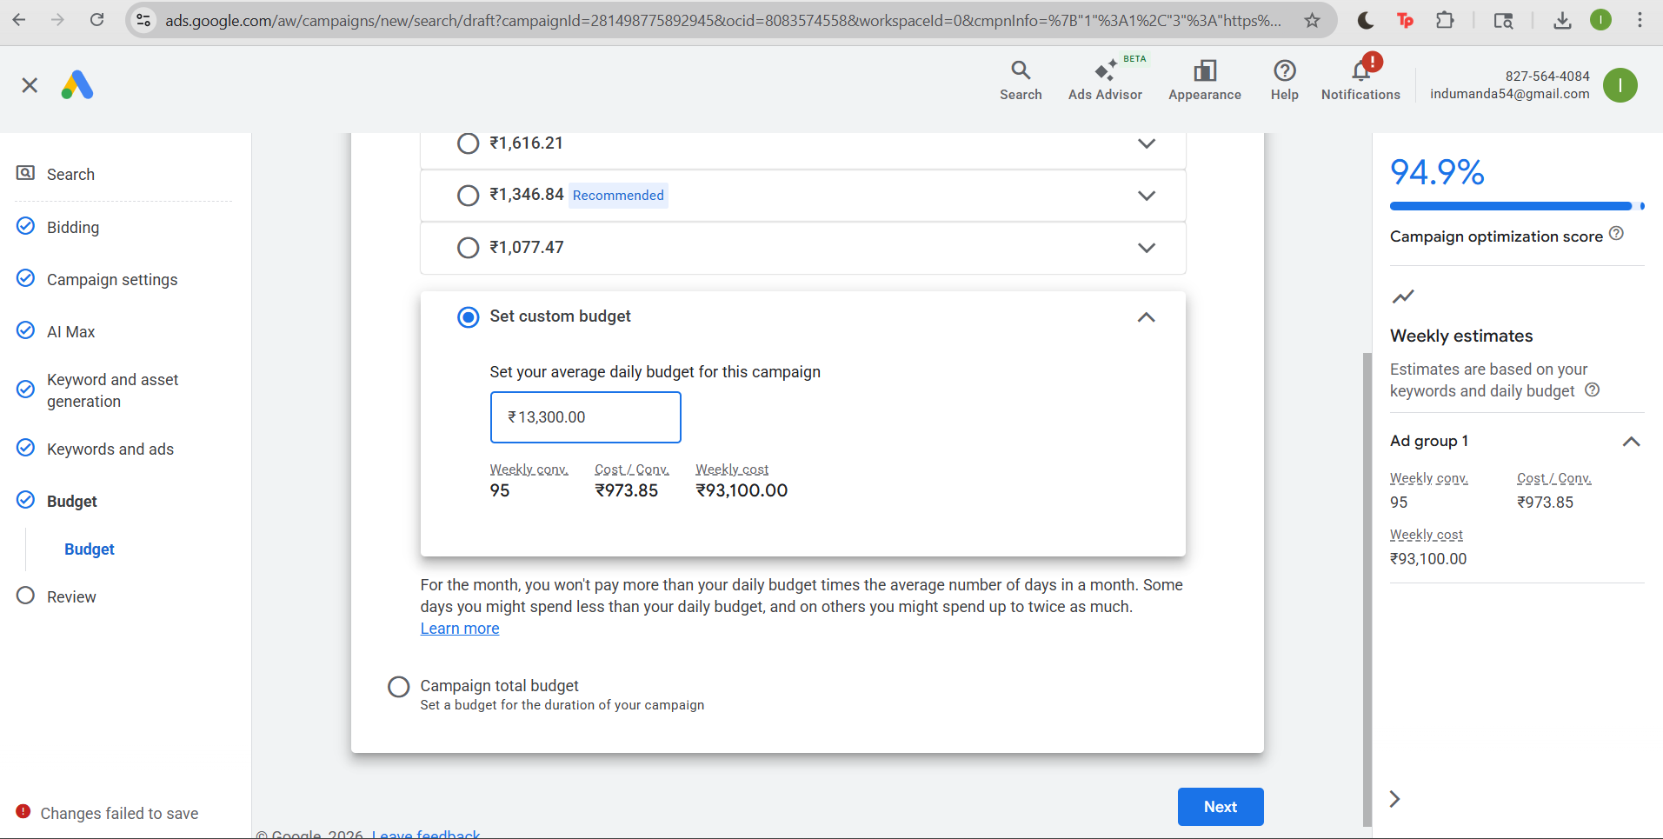

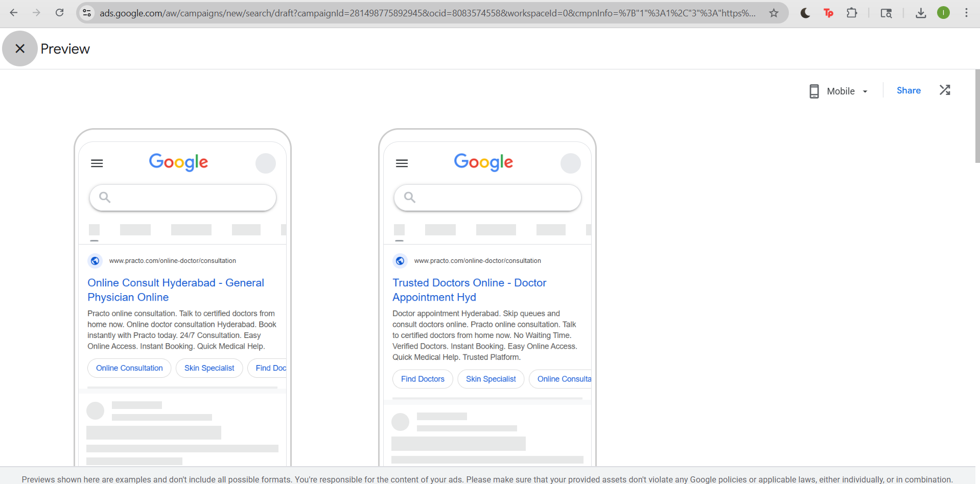

Display Ads

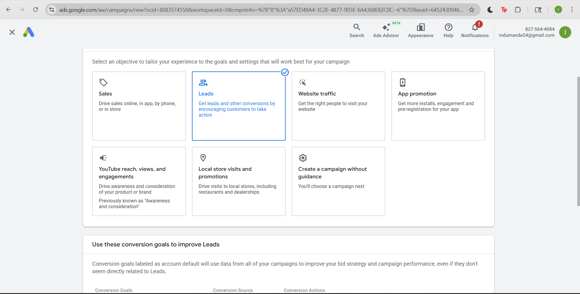

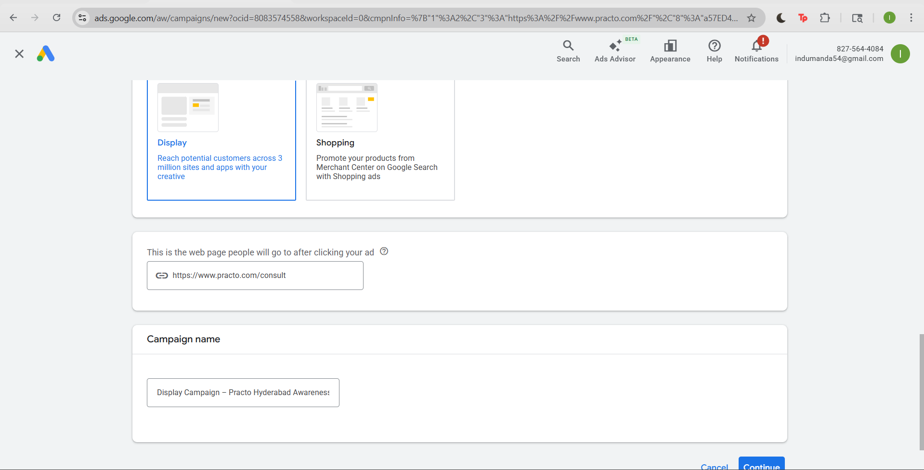

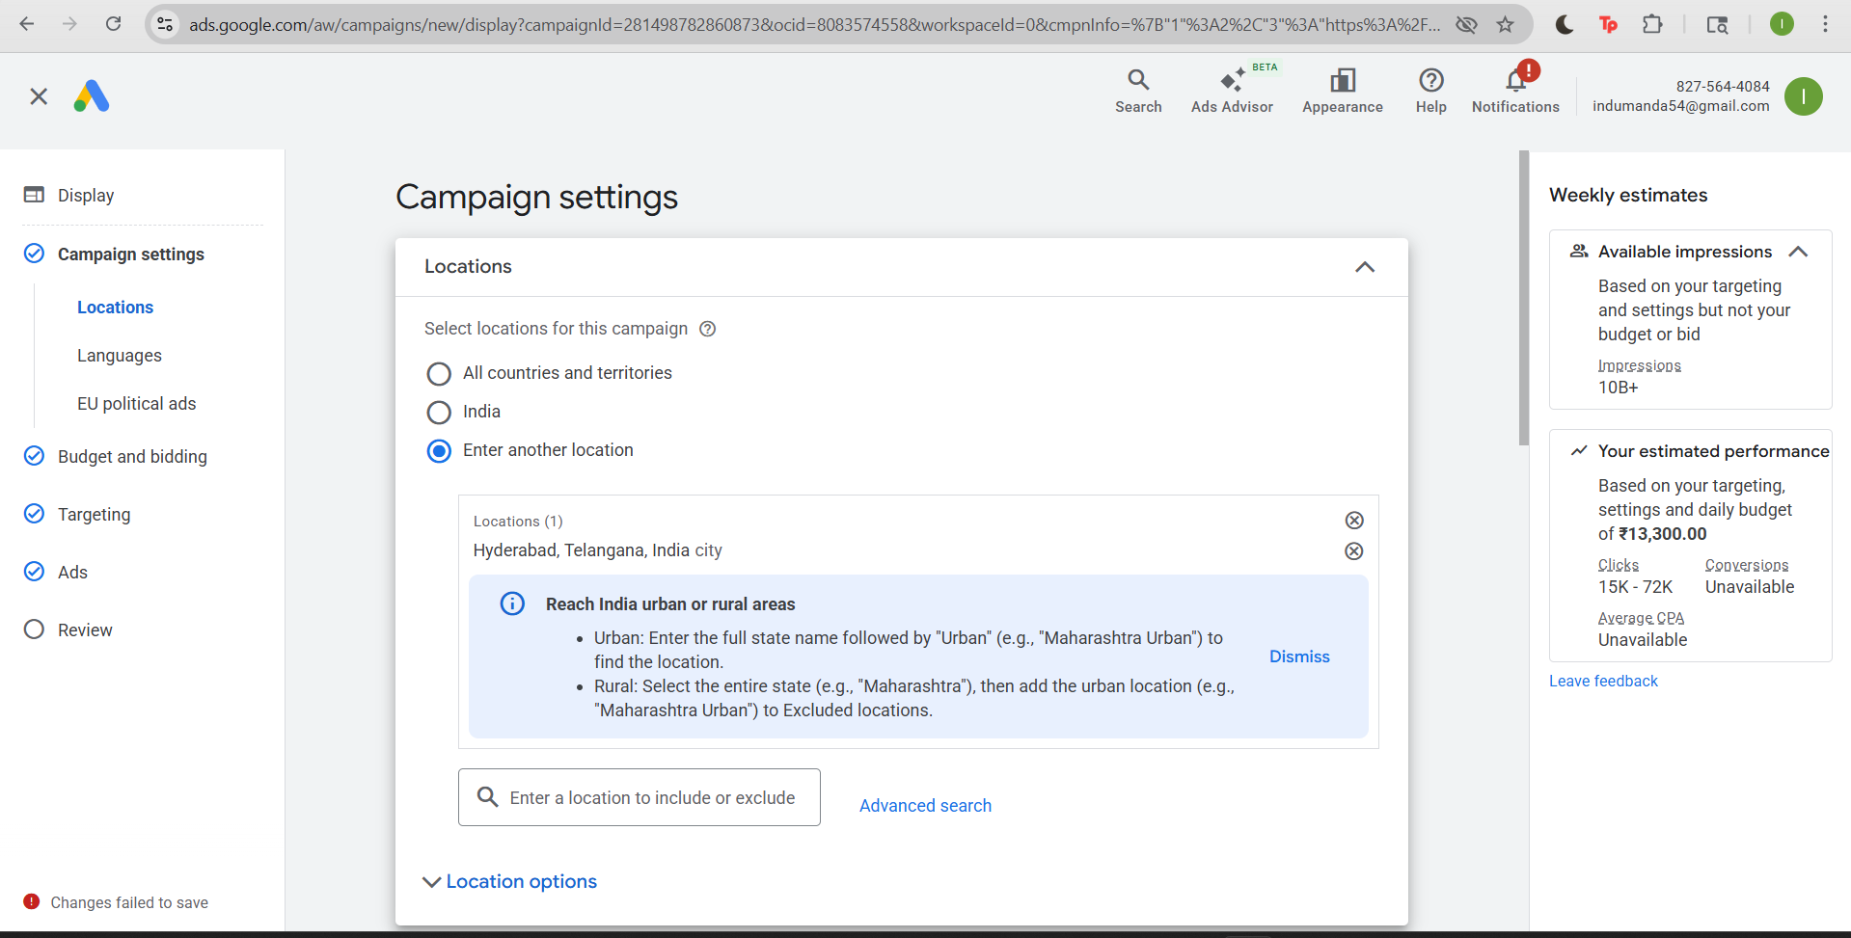

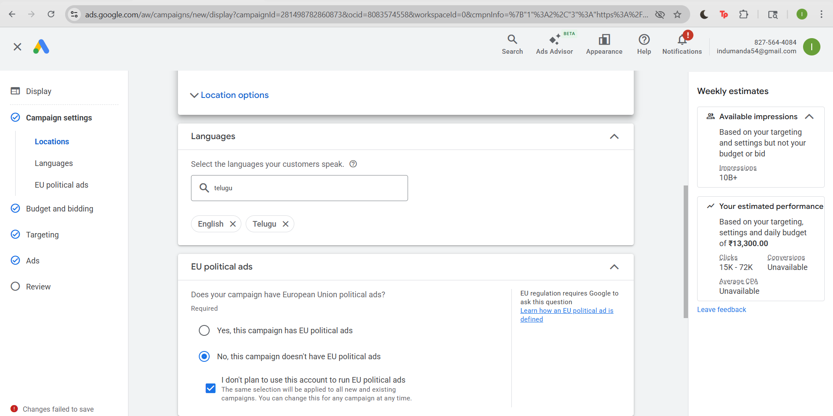

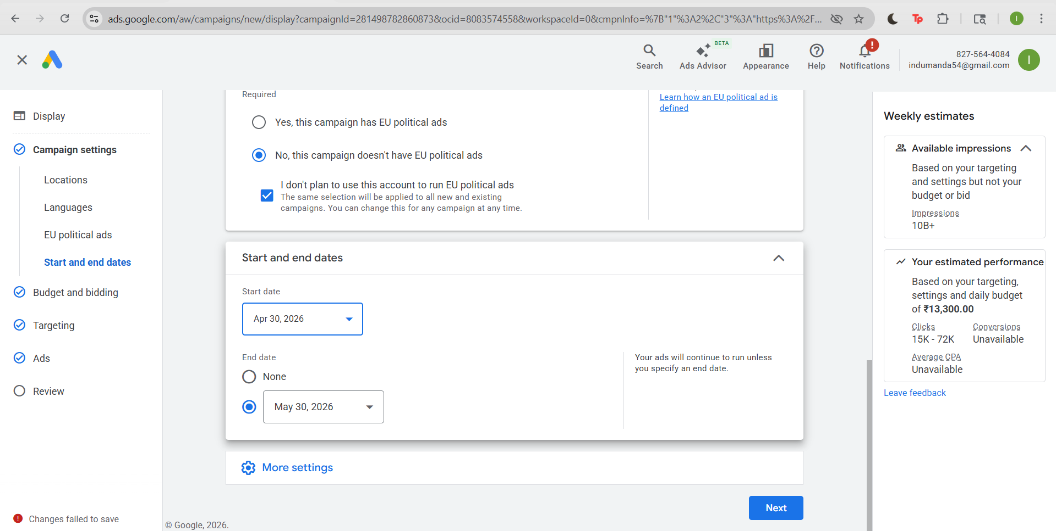

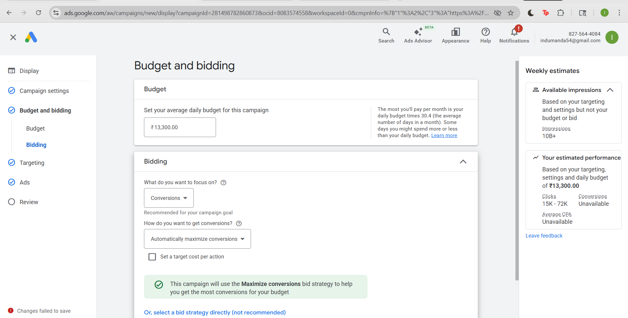

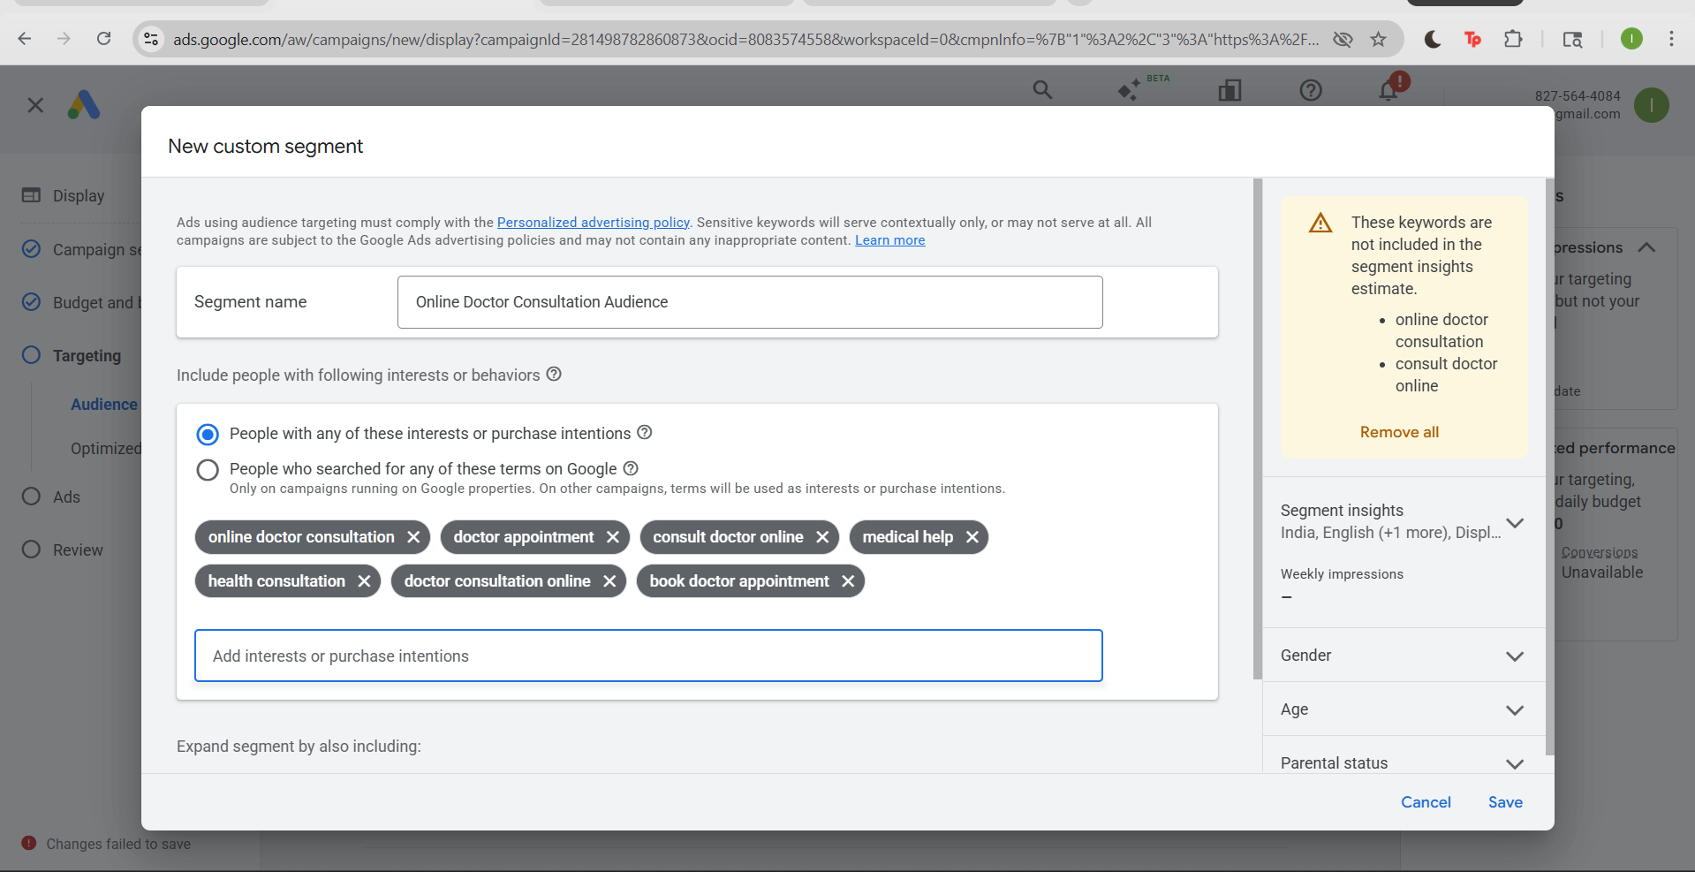

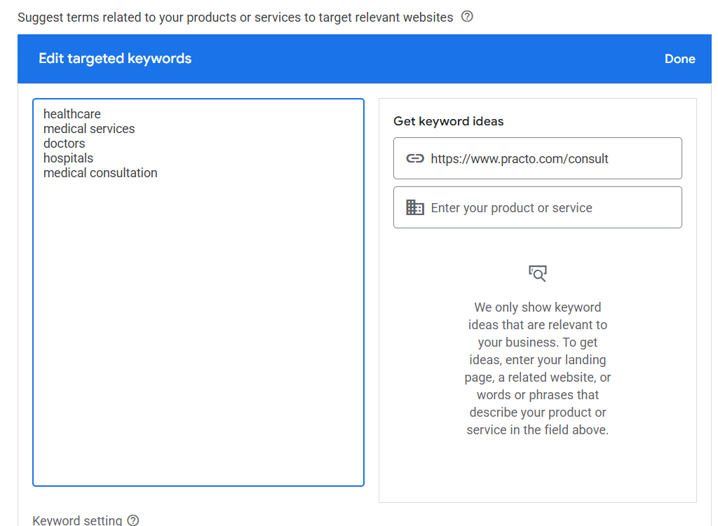
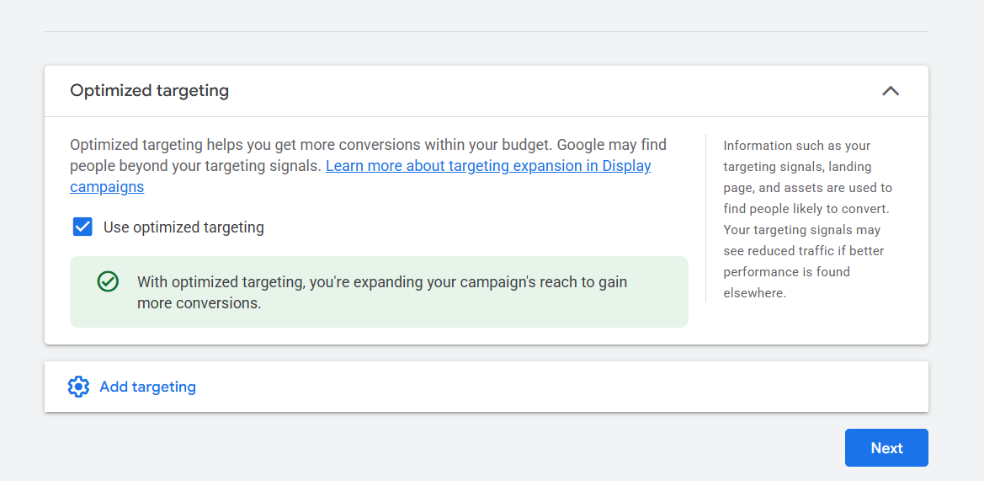

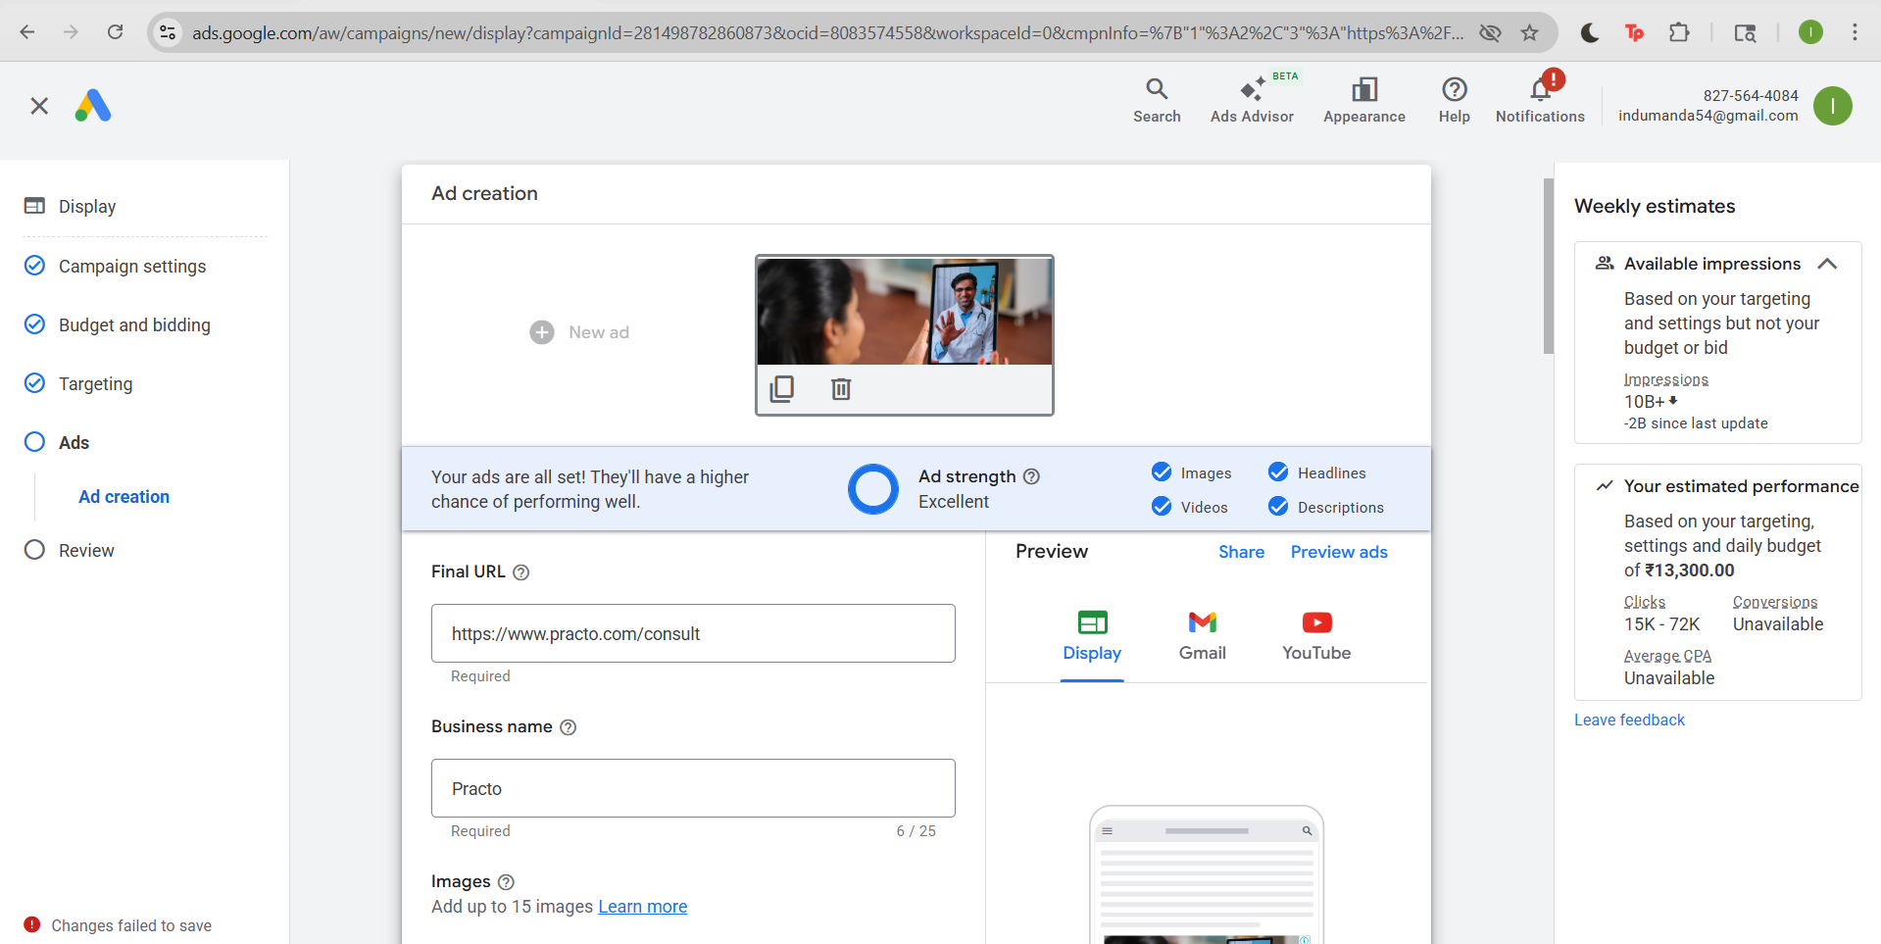

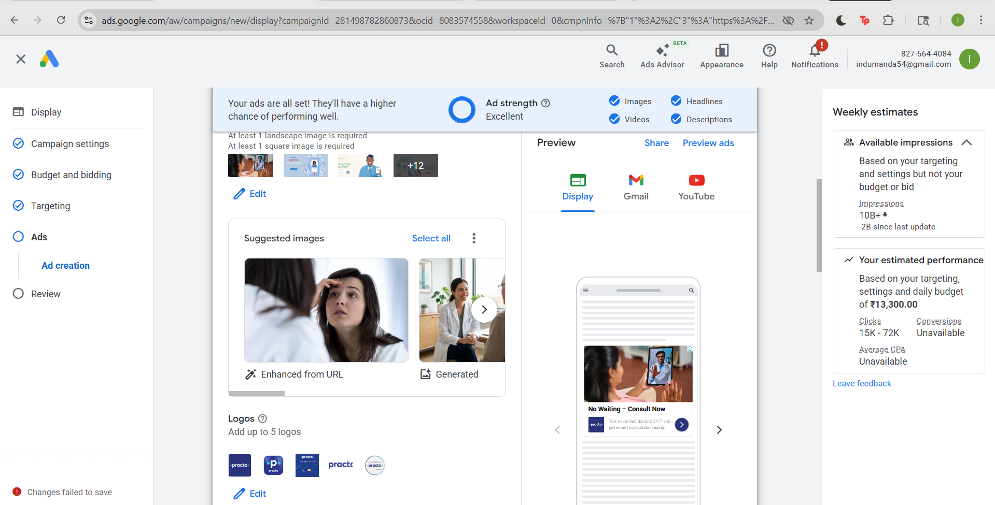

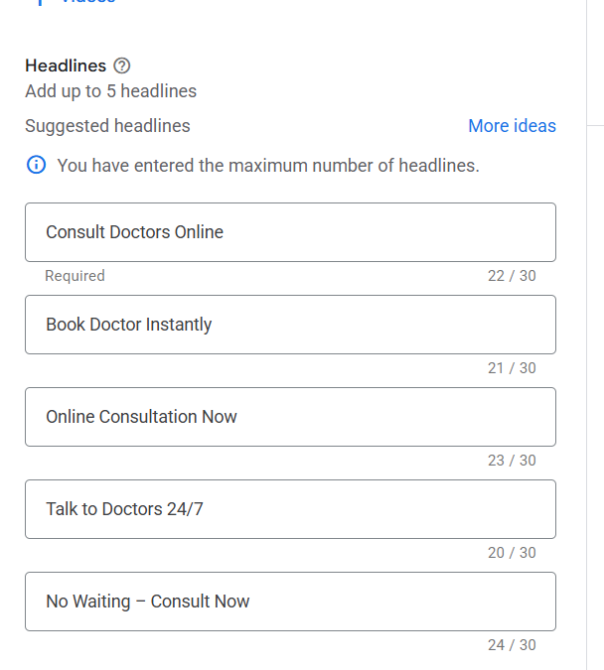

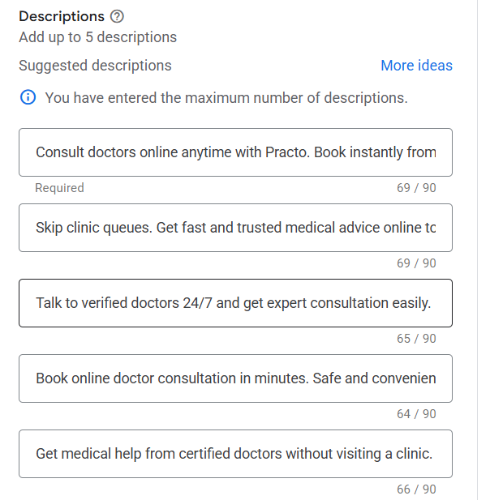

Competitor research

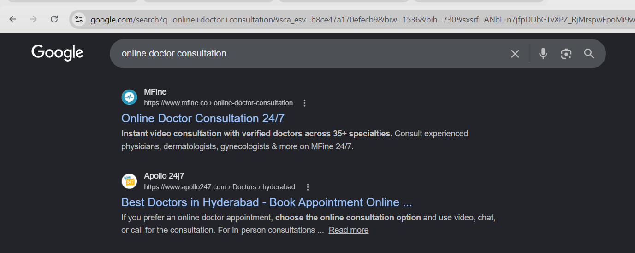

Search Ads copy and extensions

Keywords
"online doctor consultation Hyderabad"
[doctor appointment hyderabad]
"book doctor appointment online"
"consult doctor online"
"dermatologist online consultation"
"consult skin specialist online"
"general physician online consultation"
"general physician online”
"doctors online booking"
"doctor appointment app"
"practo online consultation"
"online doctor consultation"

DISPLAY PATH

Path 1: online-doctor
Path 2: consultation

15 HEADLINES (≤30 characters)
- Book Doctor Online Now
- Doctor Appointment Hyd
- Online Doctor Consult
- Consult Doctor Online
- Practo Online Consult
- Skin Specialist Online
- Dermatologist Online
- General Physician Online
- Instant Doctor Booking
- Consult Doctors 24/7
- Book Appointment Fast
- Trusted Doctors Online
- Online Consult Hyderabad
- No Waiting Consult Now
- Quick Doctor Booking

6 DESCRIPTIONS (≤90 characters)
- Online doctor consultation Hyderabad – Book instantly with trusted doctors.
- Doctor appointment Hyderabad – Skip queues and consult doctors online.
- Book doctor appointment online quickly and get expert medical advice.
- Consult doctor online anytime with verified doctors on Practo.
- General physician online consultation – Fast and reliable care at home.
- Dermatologist online consultation – Get expert skin advice instantly.

6 SITELINKS

1. Book Appointment
Description 1: Book doctor instantly online
Description 2: Quick & easy consultation
Final URL: https://www.practo.com/consult

2. Find Doctors
Description 1: Browse verified doctors
Description 2: Choose top specialists
Final URL: https://www.practo.com/doctors
3. Online Consultation
Description 1: Talk to doctors anytime
Description 2: No waiting, consult now
Final URL: https://www.practo.com/consult/
4. Skin Specialist
Description 1: Consult dermatologists
Description 2: Get expert skin advice
Final URL: https://www.practo.com/consult/dermatologist
5. General Physician
Description 1: Get medical advice fast
Description 2: Consult online instantly
Final URL: https://www.practo.com/consult/general-physician
6. Book Doctors Hyderabad
Description 1: Find doctors near you
Description 2: Book in Hyderabad now
Final URL: https://www.practo.com/hyderabad

CALLOUTS
- 24/7 Consultation
- Verified Doctors
- Instant Booking
- No Waiting Time
- Trusted Platform
- Easy Online Access
- Quick Medical Help
- Secure Consultation

Display Ads copy and extensions
Keywords
healthcare
medical services
doctors
hospitals
medical consultation

Customer Segment
Online Doctor Consultation Audience
consult doctor online, doctor consultation online, doctor appointment, medical help, online doctor consultation, book doctor appointment, health consultation

Long Headline
Consult Doctors Online Anytime from Home Easily

FINAL URL
https://www.practo.com/consult

Headlines
- Consult Doctors Online
- Book Doctor Instantly
- Online Consultation Now
- Talk to Doctors 24/7

No Waiting – Consult Now

DISPLAY AD DESCRIPTIONS
- Consult doctors online anytime with Practo. Book instantly from home.
- Skip clinic queues. Get fast and trusted medical advice online today.
- Talk to verified doctors 24/7 and get expert consultation easily.
- Book online doctor consultation in minutes. Safe and convenient.
- Get medical help from certified doctors without visiting a clinic.

.

